**Zimbabwe willing to use Iran's expertise in health, environment**

1. [Society](https://www.tehrantimes.com/service/society)

May 8, 2024 - 15:53

[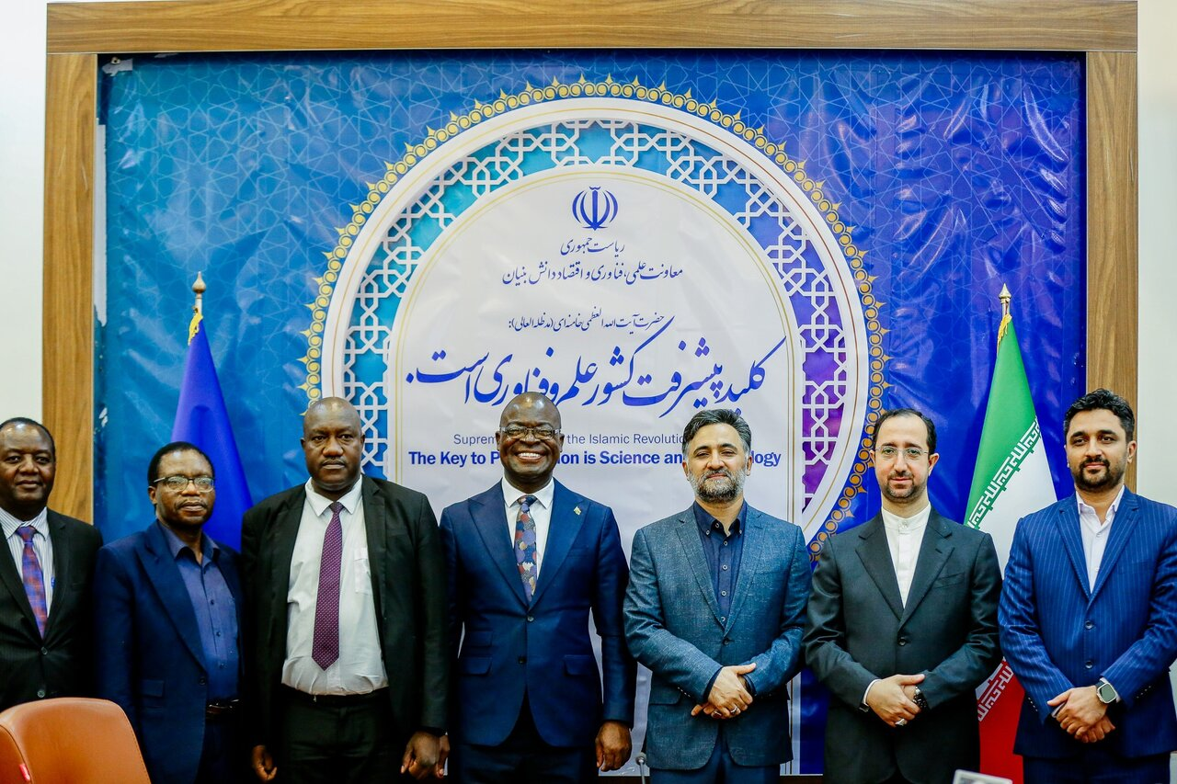](https://media.tehrantimes.com/d/t/2024/05/08/4/4974953.jpg?ts=1715170925654)

TEHRAN -Zimbabwe has expressed interest in utilizing Iran’s capabilities and experiences to boost technology in the fields of health and environment, and also agriculture and aerospace.

Attending a meeting on Wednesday in Tehran, Amon Murwira, Zimbabwe’s Minister of Higher and Tertiary Education, Science and Technology Development, and Rouhollah Dehqani-Firouzabadi, the Vice President for Science, Technology, and Knowledge-based Economy, discussed ways to boost cooperation between the two countries in various sectors, ISNA reported.

Referring to Zimbabwe’s rich natural resources, Murwira said knowledge and technology are needed to be able to use these resources;  Iran's scientific and technological capabilities can help the country to enhance its services, increase welfare, and make progress. So it welcomes scientific, innovation, social, and industrial cooperation with Iran.

The official went on to say that Iran has taken great strides in gaining independence and making notable progress, Zimbabwe is willing to learn from Iran's experiences to bring dignity and honor to Zimbabweans by using technology and innovation.

Also, he stressed the country’s readiness to strengthen strategic ties with Iran, particularly in the field of science and technology, via establishments of joint committees and working groups.

Dehqani-Firouzabadi, for his part, said that the two countries have reached an agreement to collaborate on projects with joint ownership of infrastructure, investments, knowledge, and technologies. Both sides hope to develop a platform for manufacturing high-quality joint products in the near future.

**Iran plans to strengthen African ties**

On April 30, Iranian Foreign Minister Hossein Amir Abdollahian stated that Iran is determined to strengthen and expand its relations with African nations based on mutual interest and respect.

The top diplomat made the remarks during a meeting with the Central African Minister for Small and Medium-sized Enterprises. During the meeting, Amir Abdollahian highlighted the importance of expanding relations with the African continent as a key priority of Iran's foreign policy.

The official expressed Iran's readiness to enhance bilateral cooperation with Central Africa, especially in areas such as agriculture, science, technology, and education.

Ngate Robard, for his part, commended Iran for its hosting of the second Iran-Africa Summit and Expo Tehran 2024, emphasizing the significance of these events.

The Central African Minister also praised Iran's advancements in various scientific, technological, and industrial sectors, while acknowledging the warm hospitality extended during his visit.

Iran has been seeking to strengthen ties with African nations since President Raisi’s administration took office. Raisi visited Kenya, Uganda, and Zimbabwe last year, and signed various documents to up bilateral cooperation in different fields.

During a meeting held in Tehran on May 1,  Zarepour, and the Minister of Trade and Industrial Development of Tanzania, Omar Said Shaaban, agreed on developing cooperation in areas related to information and communication technology, IRNA reported.

Lauding the expertise of Iranian companies in the field of information and communication technology, Said Shaaban expressed optimism that Tanzania would benefit from the capabilities of Iranian companies to develop ties between the two countries.

Zarepour, for his part, referred to Iran's strategy to enhance relations with African countries, especially Tanzania, announcing Iran's readiness to take steps in this regard.