**Giant steel plant to stimulate economic growth**

 dayton

2 days ago

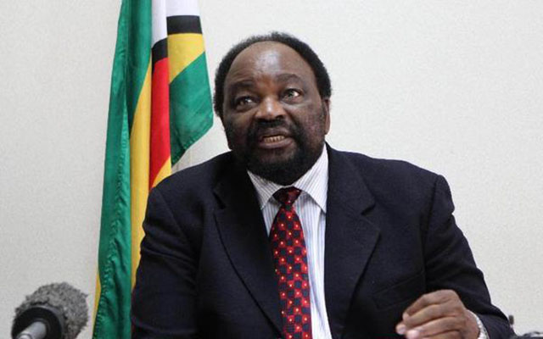

In an interview during President Mnangagwa’s recent tour of the Manhize steel plant, Zanu PF’s Secretary for External Relations Cde Simbarashe Mumbengegwi said only the total and unequivocal removal of the illegal embargo would be accepted by Zimbabwe. The country, he said, was lining itself up for unprecedented growth albeit under the yoke of sanctions.

**Wallace Ruzvidzo-Herald Reporter**

ZIMBABWE is winning the war against illegal sanctions imposed by the US and its allies, as the country continues to score major developmental milestones, setting the tone for the attainment of Vision 2030.

The development and industrialisation drive under the Second Republic has seen the implementation of projects such as the Dinson Iron and Steel Company’s plant in Manhize, Midlands province which will anchor Zimbabwe’s economic growth and modernisation, and the recent discovery of gas and oil deposits in Muzarabani, Mashonaland Central.

These projects have thus drawn the attention of the US and her allies as they would be interested in Zimbabwe’s resources hence the recent nomenclature adjustment to their sanctions regime.

In an interview during President Mnangagwa’s recent tour of the Manhize steel plant, Zanu PF’s Secretary for External Relations Cde Simbarashe Mumbengegwi said only the total and unequivocal removal of the illegal embargo would be accepted by Zimbabwe. The country, he said, was lining itself up for unprecedented growth albeit under the yoke of sanctions.

“As we all know, there was never any reason or basis for the imposition of sanctions. The sanctions have always been illegal, those who deserve sanctions are put under sanctions by the UN Security Council, not by individual member states who are pursuing their neo-colonial objectives.

“Therefore, any movement which they make on sanctions is meaningless unless the sanctions are removed in their entirety. When you have got the leadership of your country under sanctions then the whole country is under sanctions. It’s just simply playing with words to say some people have been removed, people who do not matter and yet the leadership is a critical element in any country and, therefore, as far as we are concerned the sanctions must go in their entirety,” Cde Mumbengegwi said.

When asked where Zimbabwe would be in terms of development had it not been for the punitive measures, Cde Mumbengegwi, who is a former Minister of Foreign Affairs, said “very far”.

Zimbabwe will be commemorating its Independence Day in a few weeks’ time, and Cde Mumbengegwi said the issue of land had been the major inspiration behind the liberation struggle, hence it was unfair that the country was being punished for repossessing its land through the sanctions.

“We would be very far indeed because by the time these sanctions were introduced our economy was on flight and everyone was busy in their respective areas in building our country”

And the repossession of our land was a critical element in our national development programme, the land question was one of the catalysts for the liberation struggle.

“We all wanted our land back, we got our land back and now we got punished for it, how do you get punished for simply recovering your stolen property? Surely if anyone is to be punished its the thieves who had stolen our land,” he said.

Cde Mumbengegwi said the US’ so-called review of sanctions was not only in response to Zimbabwe’s current development and discoveries thereof but also due to international pressure.

Over the years, Zimbabwe has garnered support from SADC and many countries across the globe in calling for the removal of the illegal sanctions.

In 2021, the United Nations (UN) deployed a Special Rapporteur on the negative impact of unilateral coercive measures on the enjoyment of human rights, Professor Alena Douhan, and in her findings, she urged the US to unconditionally remove the sanctions as they were causing untold suffering on the general citizenry.

Her report is set to be tabled in Geneva sometime this year.

“The current efforts by the United States to hoodwink the international community by pretending to have adjusted some of the sanctions is a response to the international pressure that has been exerted upon them. More and more countries have come out to speak against sanctions.

“On top of that, you remember that a couple of years ago the United Nations sent a Special Rapporteur. The lady came here to assess the impact of sanctions on ordinary people, and she produced a damning report against the Americans. This report is due to be debated later this year and we suspect that these so-called adjustments by the United States are efforts to try and build up some kind of defence for themselves when this report gets debated and discussed in Geneva this year,” Cde Mumbengegwi said.

Mines and Mining Development Minister Zhemu Soda said the successful implementation of development projects has positioned Zimbabwe among the ranks of global steel manufacturing hubs, and is a game changer for the country’s economic performance.

“Besides harnessing the mineral wealth for the benefit of all Zimbabweans, the Disco plant, which is poised to commence production imminently, represents more than just a facility for extraction and processing of minerals,” he said.

“It is the cornerstone of a larger vision, the creation of a mining town, which will serve as a hub for innovation and economic growth focusing on beneficiation and value addition.”

The company is expected to produce a range of products such as steel pipes, bolts and nuts, smaller slags, rolled tubes, fences, shafts, wires, and bars, among other value-added goods.

Minister Soda said the fact that the mega-investment project encompasses the establishment of a Smart City to be called Manhize Town and plans for a science university, demonstrates the huge impact of the investment.

“I would like to report that Disco is on track to achieving significant milestones in the coming months. By the end of April this year, we anticipate the production of pig iron followed by the production of steel billets and steel bars by October 2024,” he said.

“These accomplishments will lay the foundation for a robust production capacity with projections indicating a steady increase over subsequent phases.”

Preliminary reports already suggest that the new steel plant will produce 600 000 tonnes of products with plans to scale up to 1,2 million tonnes in the second phase, 3,2 million tonnes in the second phase and ultimately five million tonnes per year in the final phase.

Minister Soda said such ambitious targets underscore the potential for Disco to become a major player in the steel market in the world.

Political commentator Mr Godwin Mureriwa said it was encouraging to note that Zimbabwe was spearheading industrialisation-driving projects even under the yoke of punitive measures.

“The big project is significant because Zimbabwe has always been a major player in terms of steel production so if Manhize becomes the biggest on the continent then it will be great for infrastructure development not only in Zimbabwe but the continent.

“There is no industrialisation that happens without steel so it will be very big. It is a massive project and it will also be good for employment creation so it is a very important milestone,” he said.

Harare based political analyst Dr Leopold Chakanyuka said the current development and achievements of the Second Republic had shown that the punitive measures were not limiting Zimbabwe to the extent hoped by the US.

“When you look at the Manhize project, that is a multibillion dollar project which is going to feed into our economy. You will see infrastructure development and locals are also going to benefit from industry because it’s going to create employment.

“Manhize is going to be one of the biggest steel companies on the continent which will get us exports and also the construction sector in our country will also improve and even the discovery of oil and gas is another opportunity which will contribute well.

“The sanctions being there have not limited us and that is what the President has tried to do, so yes we are thriving even in the face of sanctions” he said.