**Tehran, Harare Mull over Expansion of Industrial Co-op**

1. [Economy](https://www.tehrantimes.com/service/economy)

March 4, 2024 - 15:0

[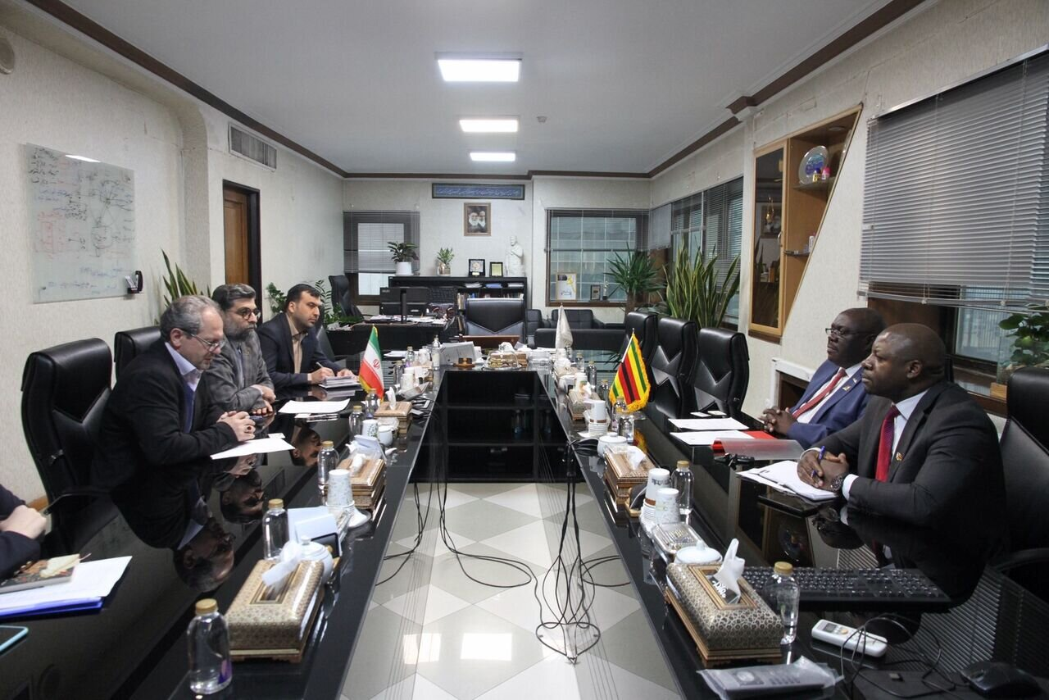](https://media.tehrantimes.com/d/t/2024/03/04/4/4889623.jpg?ts=1709545514855)

TEHRAN - The Head of Iran Small Industries and Industrial Parks Organization (ISIPO) Farshad Moghimi has expressed the country’s readiness for the expansion of economic and industrial cooperation with Zimbabwe.

Moghimi made the remarks in a meeting with the African country’s Ambassador in Tehran Bright Kupemba, IRNA reported.

Speaking at the meeting, the ISIPO head referred to the industrial capabilities of Iran, and said: “More than 52,000 industrial units are active in various industrial and production fields under the supervision of the ISIPO, and this sector is considered a very suitable capacity for promoting the economic relations between the two countries.”

“We are ready to provide the grounds for Zimbabwean business delegations to visit Iran's industrial infrastructures and capable production units with a special focus on business communication between the two countries,” he said.

Moghimi further announced Iran’s readiness to supply industrial items needed by Zimbabwe and said: "Zimbabwe can use Iran’s expertise in technical and engineering services, modernizing and improving industries, supplying industrial and agricultural machinery and equipment, diagnosing problems, etc.”

The Ambassador of Zimbabwe in Tehran also described Iran's industrialization approach as an admirable model and said: “We would like to use Iran's experiences in the field of industrialization as an important priority to activate Zimbabwe's industrial capacities.”

“A delegation from Zimbabwe will travel to Iran to visit the capacities of small and medium-sized enterprises (SMEs) and the capabilities of the private sector in order to provide the basis for the promotion of trade and economic relations between the two countries,” Kupemba said.