**Iran is a Strategic Partner for Zimbabwe in Economic Development**

Zimbabwe, a landlocked country, borders South Africa to the south, Botswana to the southwest, Zambia to the north, and Mozambique to the east. Its vast and diverse territory, spanning some 390,000 square kilometers, showcases a range of stunning landscapes, from lush savannahs and majestic mountains to the spectacular UNESCO World Heritage-listed Victoria Falls. Also, the country's unique flora and fauna, which includes a significant variety of wild animals such as lions, elephants, and rhinos, is a unique natural treasure. However, Zimbabwe has faced numerous political and economic challenges since its independence in 1980. Despite this, this country has an undeniable potential for development. Among these potentials, we can mention its young and dynamic population, which is considered a valuable asset for the future of this country, as well as its rich mineral resources, especially gold, chrome and platinum, along with its fertile lands, which provide promising prospects for Zimbabwe offers.

**Diplomatic Voice's exclusive conversation with Mr. Bright Kupemba, Ambassador Extraordinary and Plenipotentiary of the Republic of Zimbabwe in Iran**

**Your Excellency, what diplomatic positions have you held before? How will your experiences and expertise in the field of diplomacy help to improve the relations between the two countries of Iran and Zimbabwe?**

I have a long diplomatic career of more than three decades and have served in various regions of the world, including in Europe and Africa. It is this experience that helps to navigate in the complex diplomatic field of the Middle East and most importantly to ensure the existence of stable relations between Zimbabwe and Iran.

**What tangible achievements has the recent meeting between the presidents of Iran and Zimbabwe in Harare brought to the two countries?**

Certainly, this meeting raised relations to another level and indicated a review of bilateral relations with a focus on economic diplomacy.

**Have new agreements and contracts been signed between the officials of the two countries during this trip?**

As a general matter, it can be mentioned that during the official visit of President Raisi to several sectors of socio-economic activities, including health and agriculture, about twelve memorandums were signed.

**What role can the Islamic Republic of Iran play in solving the problems and challenges facing Zimbabwe?**

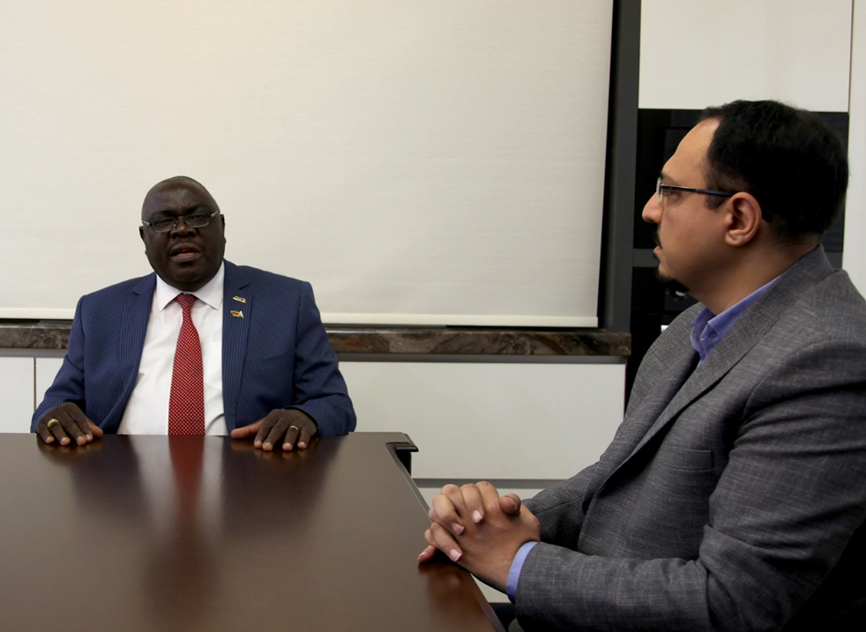

Zimbabwe and Iran are countries that are subject to unilateral and illegal sanctions by the United States and its allies due to the determination and similar policy of resource nationalism.

In these 45 years that Iran has been under sanctions, it has been able to overcome the impossible and register extraordinary development indicators. In this regard, the Islamic Republic turned to its internal resources and capacities to create superiority.

Zimbabwe, with the slogan *"Nyika inovakwa nevene vayo"* meaning "Zimbabwe must be built and developed by Zimbabweans", has adopted a similar internal model for rapid development processes in the face of traditional sources of hostile forces. Therefore, Zimbabwe can follow the example of Iran, which has acted wonderfully under the heavy sanctions of the West.

**What role can Iran play in the development and progress of Africa?**

In the framework of South-South cooperation, Iran can play a significant role in transferring knowledge in various fields, transferring technology, trade and creating added value for Africa's abundant natural resources.

With the emergence of the African Continental Free Trade Area (ACFTA), there is an opportunity for trade-oriented development.

**Considering the rich cultural capacities of the two countries, what programs have been adopted by the authorities of the two countries to expand cultural and scientific exchanges between Iran and Zimbabwe?**

Through the Joint Permanent Cooperation Commission (JPCC), a framework for cooperation in the fields of art and culture as well as innovation, science and technology has been established and visits/exchanges of delegations have taken place to examine various areas of scientific progress. Also, promoting tourism in Iran and Zimbabwe strengthens cultural exchanges. The mutual facilitation of the visa regime by both countries shows the commitment for a deeper connection between Meram and the people and thus the exchange of cultural experiences.

**Are there areas of joint cooperation in the fields of art, sports and tourism between the two countries?**

I mentioned that there is a joint permanent commission for cooperation between the two countries that covers various areas of human activities including art, sports and culture. The category of tourism was mentioned before; There is a memorandum of understanding in this regard, and the presence of Zimbabwe in the Tehran tourism exhibition in 2024 was the source of the expected stable cooperation in this sector.

**What was the volume of trade between Iran and Zimbabwe last year?**

The national statistics offices of the two countries have not published the final calculations yet. However, based on the activities carried out, there has been a significant increase.

**What are the areas for joint investment between the two countries?**

There are many opportunities for joint investment between Zimbabwe and Iran, especially in fields such as mining, agriculture, factory production and health. Agriculture and health are easy options due to the constant demand for agricultural products and medical services.

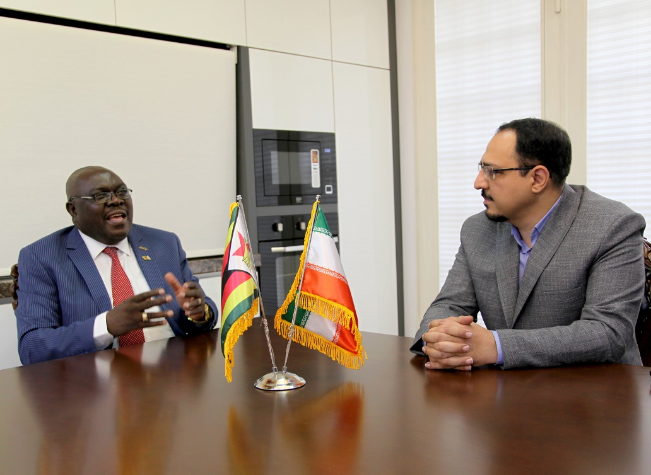

**Name the most important export and import items between the two countries?**

Considering Zimbabwe's ability in agriculture, Iran's imports from Zimbabwe tend towards this sector, especially horticultural products and cash products. Zimbabwean businessmen are also interested in importing petrochemical products from Iran such as oils, lubricants, fertilizers and bitumen.

**What measures have been taken to strengthen scientific and technological cooperation between Iran and Zimbabwe?**

The Islamic Republic has taken great strides in the field of innovation, science and technology development, which Zimbabwe is interested in achieving. From this point of view, scientific and technological cooperation is one of the main areas of cooperation within the framework of the Joint Permanent Cooperation Commission. In this regard, exchange programs and knowledge transfer initiatives are underway between Zimbabwean and Iranian technology-oriented institutions and organizations.

**What cooperation do Iran and Zimbabwe have with each other in the fields of education, exchange of professors and students, conducting joint research and awarding scholarships?**

Considering the important role that academies play in shaping the destiny of people and governments, educational cooperation provides a solid basis for mutual understanding. Therefore, Zimbabwe and Iran have decided to accelerate educational cooperation through research and development (R&D) and the awarding of scholarships, especially in the important fields of engineering and medical sciences.

**What was the number of tourists who traveled to each other's countries last year ? What measures have been taken to facilitate the travel of tourists between the two countries? What are the challenges in the development of tourism relations between Iran and Zimbabwe?**

Tourism between Zimbabwe and Iran has not been so lively. Nevertheless, after the Covid-19 pandemic, the arrival of tourists from Iran to Zimbabwe increased significantly.

However, more work is needed to market tourism destinations and products in each other's countries. It is hoped that the mutual facilitation of the visa regime in the two countries can increase the number of incoming tourists to both destinations.

The presence of Zimbabwe in the Iran International Tourism Exhibition in 2024 can be considered an important step towards strengthening cooperation in the tourism sector.

**What is the Zimbabwean government's view on recent developments in the Middle East region and the war between Hamas and Israel?**

The government of Zimbabwe always condemns the loss of human lives in war, and the Hamas-Israeli war is no exception to this rule. Harassing people should end and a diplomatic solution should be sought to resolve this conflict and establish peaceful coexistence.

**What role can Iran and Zimbabwe play in the development process and peace in Africa?**

Iran is a vital and strategic member of the South global community, in which Africa is considered an important player in the emerging multipolar world now and in the future.

The cooperation between Iran and Zimbabwe should be seen as a small world of relations between Iran and other African countries and the entire global south in an effort to guide development processes in Africa and other deprived areas of the world.

Iran's accession to BRICS should also be considered as a positive development in the form of a desire to create peace and development at the world level.